You Are in Control A Power Grid Game for Two Players

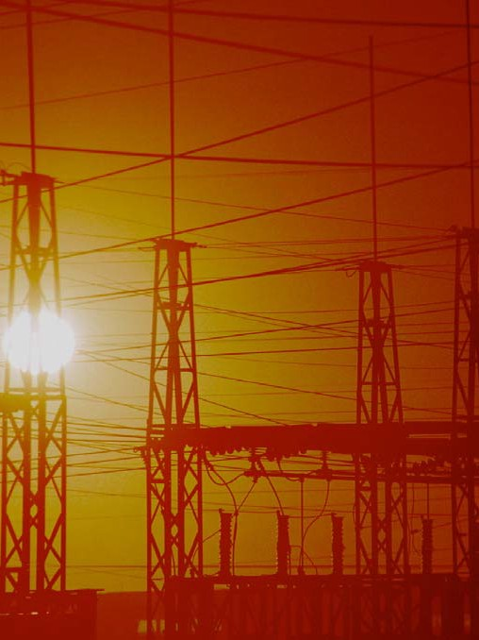

TCIP Educational Development
TCIP: Trustworthy Cyber Infrastructure for the Power Grid

You Are in Control
Rules

You and a partner will use the applet at http://tcip.mste.uiuc.edu/applet3.html and play a game to see who is better at controlling unexpected situations that may occur . Each of you will be a grid operator and make changes to your own system applet.

- Both you and your partner should have your own Power Grid applet up and running.

- Press the reset button.

- Set up your system at the start of the game so that the amount of electricity coming in from the External System is zero.

- Press the Reset Time and Show Plot buttons.

- To play the game, you and your partner take turns drawing Situation Cards. Make the necessary adjustments to your grid for each Situation Card you draw. The effects of a Situation Card must stay in place for two turns unless it is a short term problem. Short term problems may be corrected on your next turn.

- After you have made changes to your system, press Resume Time so any changes you made will be shown on the plot. Let the plot run for a few seconds then press Pause Time. This will pause the plot between your plays. Remember to press Resume Time for a few seconds after you make any changes to your system on every turn.

- Keep track of the number of blackouts that occur on your system during the game. (System Operator Record Sheets are available if you would like to fill them out for each turn.)

- When all the cards have been used, press Pause Time. The game is over.

Scoring: Each player starts with 20 points.

Look over your plot at the end of the game.

You lose a point every time there is a Blackout on your system for any reason.

You lose a point every time the emissions of your system went over 700 tons/hour. You lose a point every time your system operated at a loss instead of a profit.
Winner: The winner is the person with the most points when all of the cards have been drawn.

Because of a heat wave, Residenceburg needs more power. Increase the power by 50 MW. | A storm has knocked out the transmission lines between Substation 4 and Substation 6.
Because of a severe drought, the amount of power from your Hydroelectric plant must be decreased to 500 MW. | An ice storm has brought down the power lines to Residenceburg. Shut down these lines. This is a short term problem.  (It lasts one turn.)
Commerceton has started to conserve energy. Decrease their power to 500 MW. | Your customers only want green energy. Shut down the Coal and Natural Gas Generators.
Lightning has damaged some turbines on your wind farm. You must take the Wind Farm off- line. | The External System on the right side of the screen is experiencing problems. You must shut this down.

No Problems today. You may make any adjustment to your power grid that you think is necessary. | No Problems today. You may make any adjustment to your power grid that you think is necessary.
Repairs need to be made to your coal plant. You must reduce production by 100 MW. | Due to a peak in energy needs, you need to increase your peak loading generator (Natural Gas) to full capacity. This is a short term problem. (One turn)
The Nuclear Regulatory Commission has determined a problem with your Nuclear Generator. Shut it down. | Because of a holiday, Industryville demands only 50 MW of power.
A new state law requires that you charge your customers no more than $85/MWh. Adjust your Load Payment. | The transmission line between Substation 2 and 4 has been damaged. Shut it down.

Steady rains have filled the water supply for the hydroelectric generator. You many adjust this to any MW level. | No problems today. You may make any adjustment to your grid that you think is necessary.
Residenceburg needs another 50 MW of power. This is a short term power demand.  (It only lasts one turn.) | Storm damages line between Substation 5 and 6. Shut it down.
A new tax requires that you increase the amount you charge for energy by $1/MWh.
Adjust your Load Payment.
Coal miners have gone on strike. You do not have any coal in reserve. Shut down your coal plant.

There are two blank cards for you to use to create some of your own Situations Cards.

Start of the Game | Generators: | Power Produced or Consumed (MWs) | Check if ON-Line | Check if OFF-Line | Cost of operation or Payment
 | Nuclear
 | Wind
 | Hydroelectric
 | Coal
 | Natural Gas
 | External System
 | Consumers:
 | Residenceburg
 | Commerceton
 | Industryville
Number of Blackouts: |  | Loss:  Profit: |  | Emissions:

Situation Card # 1  (Turn 1) | Generators: | Power Produced or Consumed (MWs) | Check if ON-Line | Check if OFF-Line | Cost of operation or Payment
 | Nuclear
 | Wind
 | Hydroelectric
 | Coal
 | Natural Gas
 | External System
 | Consumers:
 | Residenceburg
 | Commerceton
 | Industryville
Number of Blackouts: |  | Loss:  Profit: |  | Emissions:

Situation Card # 2  (Turn 2) | Generators: | Power Produced or Consumed (MWs) | Check if ON-Line | Check if OFF-Line | Cost of operation or Payment
 | Nuclear
 | Wind
 | Hydroelectric
 | Coal
 | Natural Gas
 | External System
 | Consumers:
 | Residenceburg
 | Commerceton
 | Industryville
Number of Blackouts: |  | Loss:  Profit: |  | Emissions:

Situation Card # 3  (Turn 3) | Generators: | Power Produced or Consumed (MWs) | Check if ON-Line | Check if OFF-Line | Cost of operation or Payment
 | Nuclear
 | Wind
 | Hydroelectric
 | Coal
 | Natural Gas
 | External System
 | Consumers:
 | Residenceburg
 | Commerceton
 | Industryville
Number of Blackouts: |  | Loss:  Profit: |  | Emissions:

Situation Card # 4  (Turn 4) | Generators: | Power Produced or Consumed (MWs) | Check if ON-Line | Check if OFF-Line | Cost of operation or Payment
 | Nuclear
 | Wind
 | Hydroelectric
 | Coal
 | Natural Gas
 | External System
 | Consumers:
 | Residenceburg
 | Commerceton
 | Industryville
Number of Blackouts: |  | Loss:  Profit: |  | Emissions:

Situation Card # 5  (Turn 5) | Generators: | Power Produced or Consumed (MWs) | Check if ON-Line | Check if OFF-Line | Cost of operation or Payment
 | Nuclear
 | Wind
 | Hydroelectric
 | Coal
 | Natural Gas
 | External System
 | Consumers:
 | Residenceburg
 | Commerceton
 | Industryville
Number of Blackouts: |  | Loss:  Profit: |  | Emissions:

Situation Card # 6  (Turn 6) | Generators: | Power Produced or Consumed (MWs) | Check if ON-Line | Check if OFF-Line | Cost of operation or Payment
 | Nuclear
 | Wind
 | Hydroelectric
 | Coal
 | Natural Gas
 | External System
 | Consumers:
 | Residenceburg
 | Commerceton
 | Industryville
Number of Blackouts: |  | Loss:  Profit: |  | Emissions:

Situation Card # 7  (Turn 7) | Generators: | Power Produced or Consumed (MWs) | Check if ON-Line | Check if OFF-Line | Cost of operation or Payment
 | Nuclear
 | Wind
 | Hydroelectric
 | Coal
 | Natural Gas
 | External System
 | Consumers:
 | Residenceburg
 | Commerceton
 | Industryville
Number of Blackouts: |  | Loss:  Profit: |  | Emissions:

Situation Card # 8  (Turn 8) | Generators: | Power Produced or Consumed (MWs) | Check if ON-Line | Check if OFF-Line | Cost of operation or Payment
 | Nuclear
 | Wind
 | Hydroelectric
 | Coal
 | Natural Gas
 | External System
 | Consumers:
 | Residenceburg
 | Commerceton
 | Industryville
Number of Blackouts: |  | Loss:  Profit: |  | Emissions:

Situation Card # 9  (Turn 9) | Generators: | Power Produced or Consumed (MWs) | Check if ON-Line | Check if OFF-Line | Cost of operation or Payment
 | Nuclear
 | Wind
 | Hydroelectric
 | Coal
 | Natural Gas
 | External System
 | Consumers:
 | Residenceburg
 | Commerceton
 | Industryville
Number of Blackouts: |  | Loss:  Profit: |  | Emissions:

Situation Card # 10  (Turn 10) | Generators: | Power Produced or Consumed (MWs) | Check if ON-Line | Check if OFF-Line | Cost of operation or Payment
 | Nuclear
 | Wind
 | Hydroelectric
 | Coal
 | Natural Gas
 | External System
 | Consumers:
 | Residenceburg
 | Commerceton
 | Industryville
Number of Blackouts: |  | Loss:  Profit: |  | Emissions:

Situation Card # (Turn ) | Generators: | Power Produced or Consumed (MWs) | Check if ON-Line | Check if OFF-Line | Cost of operation or Payment
 | Nuclear
 | Wind
 | Hydroelectric
 | Coal
 | Natural Gas
 | External System
 | Consumers:
 | Residenceburg
 | Commerceton
 | Industryville
Number of Blackouts: |  | Loss:  Profit: |  | Emissions:

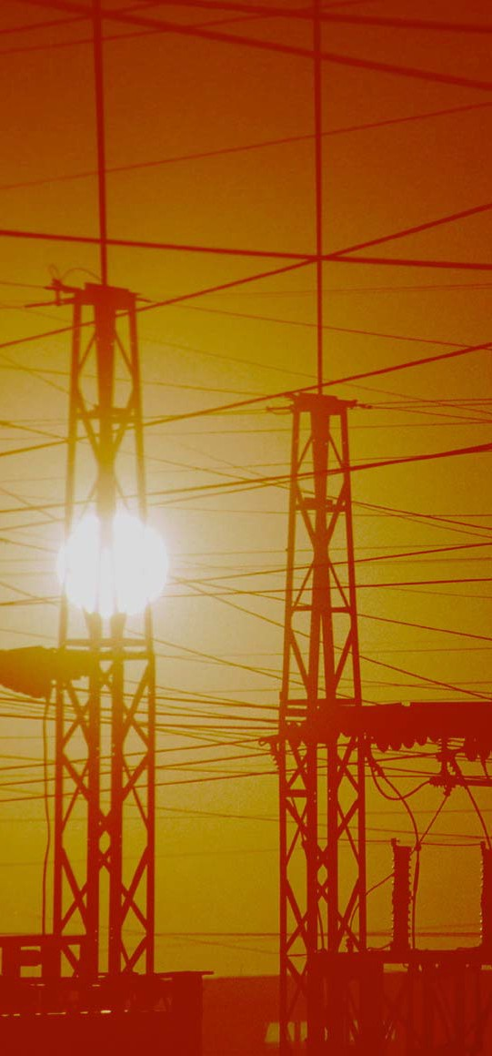
TCIP is funded by:
The National Science Foundation The Department of Energy
The Department of Homeland Security

For More Information:

Information Trust Institute University of Illinois at Urbana-Champaign
450 Coordinated Science Laboratory 1308 West Main Street, MC-228 Urbana, IL 61801

217.333.3546

info@iti.uiuc.edu http://www.iti.uiuc.edu
TCIP Educational Development is a joint project of the Office for Mathematics, Science and Technology and Information Trust Institute at the University of Illinois.
These materials were developed by Judy Rocke, Jana Sebestik and Zeb Tate in consultation with George Reese
http://tcip.mste.uiuc.edu/

